Building the network topology, involving need for level 3 connection

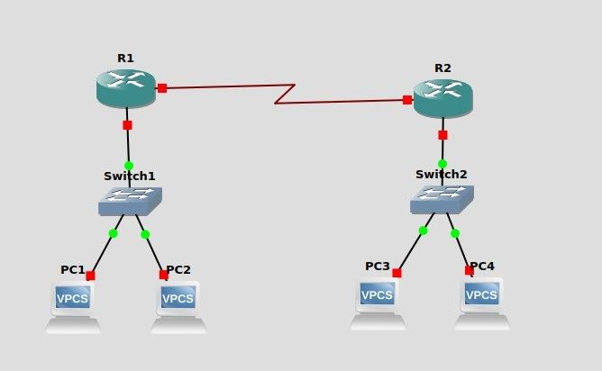

In the configuration above, PC1 and PC2 can comminucate directly through Switch1 PC3 and PC4 can communicate directly through Switch2.

However, PC1 (or PC2) cannot communcate with PC3 (or PC4) as of yet.

This is because neither of the parties involved know how to reach the other (or even if they exist yet). They are not connected to the same Local Network and hence, are virtually invisible to each other at the moment.

We will need to configure the network so that all the PCs can communicate with each other.

First, each of the interfaces on the router needs to be configured.

For the prupose of this demonstration, we will keep the networks of the PC1/2 group and the PC2/3 group different.

**On router 1:**

**To set the serial interface IP Address:** conf t interface s1/0

ip address 10.0.0.1 255.0.0.0 no shut exit

**To set the ethernet IP Address:** interface f0/0 ip address 20.0.0.1 255.0.0.0 no shut exit exit

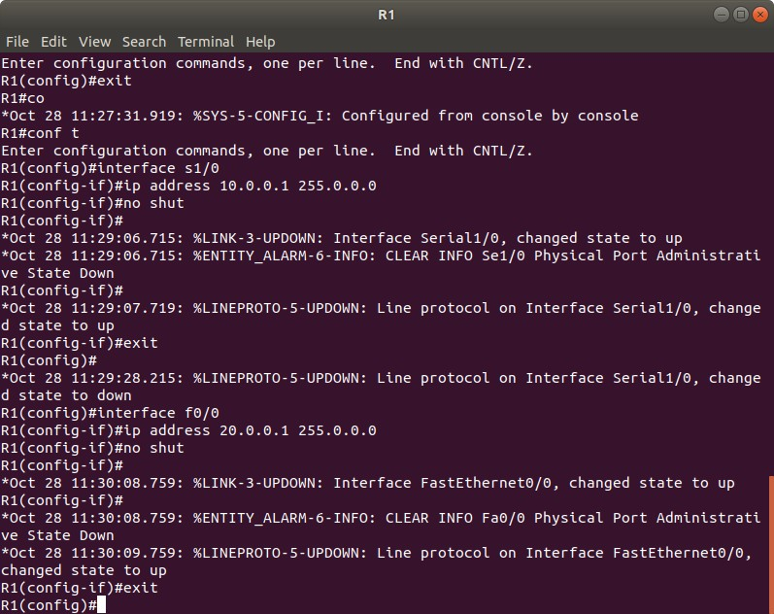

**On router 2:**

**To set the serial interface IP Address:** conf t interface s1/0 ip address 10.0.0.2 255.0.0.0 no shut exit

**To set the ethernet IP Address:** interface f0/0 ip address 30.0.0.1 255.0.0.0 no shut exit exit

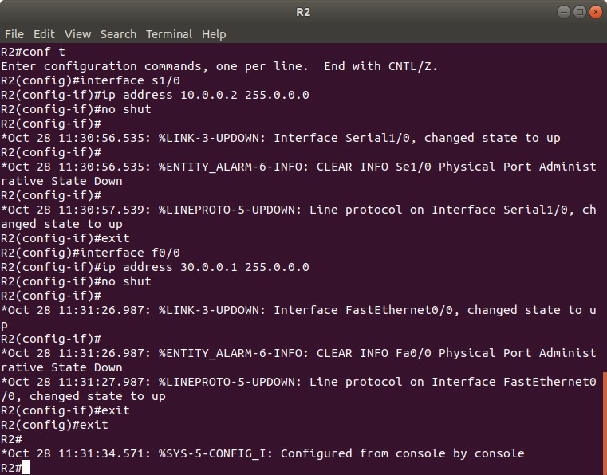

**Setting the IP Addresses of the PCs On PC1:**

ip 20.0.0.11/24 20.0.0.1

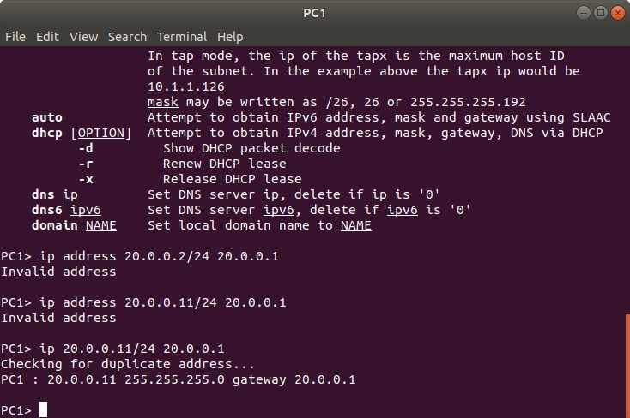

**On PC2:**

ip 20.0.0.12/24 20.0.0.1

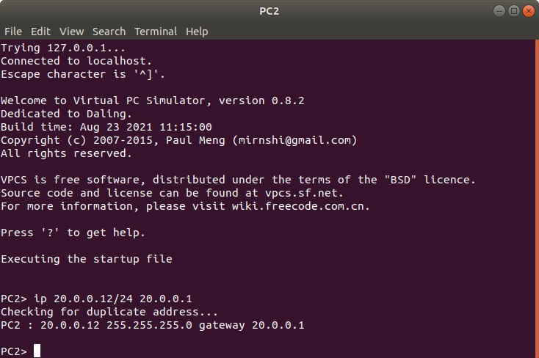

**On PC3:**

ip 30.0.0.13/24 30.0.0.1

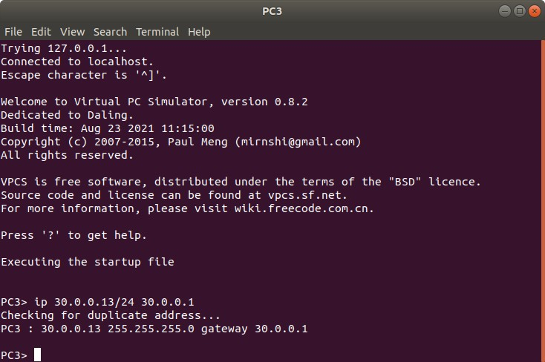

**On PC4:**

ip 30.0.0.14/24 30.0.0.1

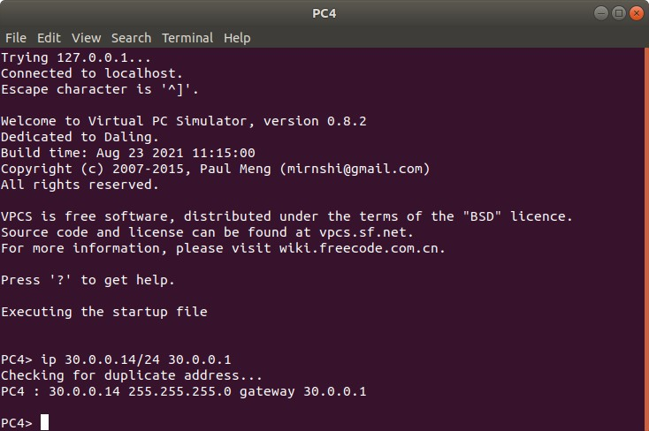

At this point, we have assigned IP Addresses to the router links and the PCs The configuration is:

Router1: s1/0: 10.0.0.1

f0/0: 20.0.0.1

Router 2: s1/0: 10.0.0.2

f0/0: 30.0.0.1

**Note that the f0/0 configurations are on different networks for the 2 routers. This is to demonstrate the need for level 3 connection.**

PC1: 20.0.0.11

PC2: 20.0.0.12

PC3: 30.0.0.13

PC4: 30.0.0.14

If we now try to communicate between PCs we will see that we can communicate between PC1 and

PC2, and between PC3 and PC4, but not between PC1(or PC2) and PC3(or PC4)

To demonstrate this, we try pinging the ip addresses of the destination pc from our source pc **Trying to reach other PCs from PC1:**

ping 20.0.0.12 // PC2

ping 30.0.0.13 // PC3

ping 30.0.0.14 // PC4

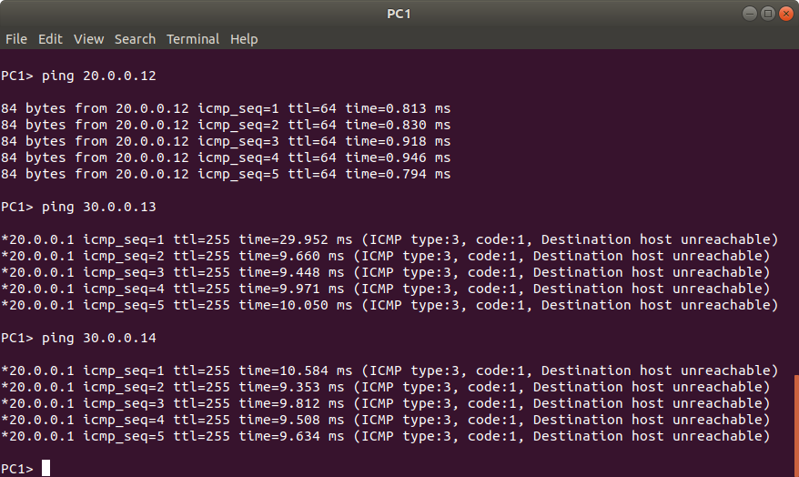

**Trying to reach other PCs from PC2:**

ping 20.0.0.11 // PC1 ping 30.0.0.13 // PC2 ping 30.0.0.14 // PC3

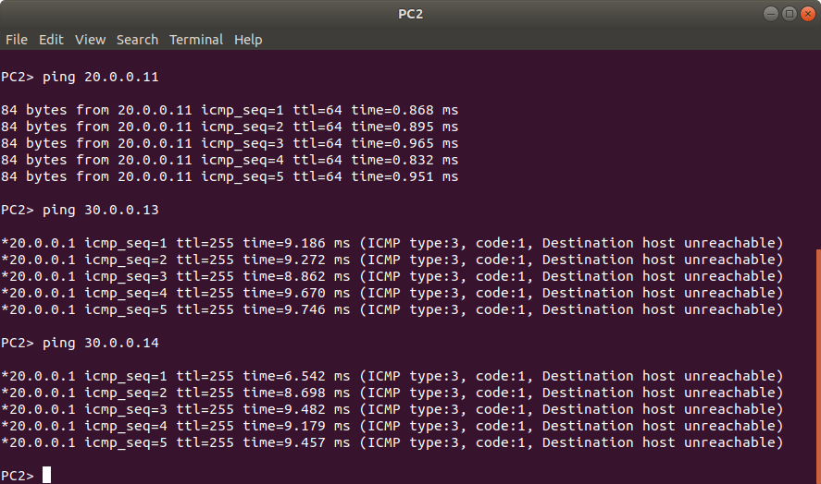

**Trying to reach the other PCs from PC3:** ping 20.0.0.11 // PC1 ping 20.0.0.12 // PC2 ping 30.0.0.14 // PC3

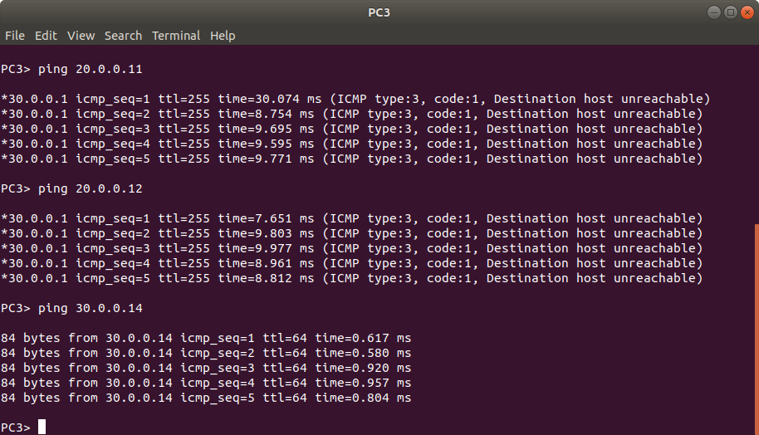

**Trying to reach other PCs from PC4:**

ping 20.0.0.11 // PC1 ping 20.0.0.12 // PC2 ping 30.0.0.13 // PC3

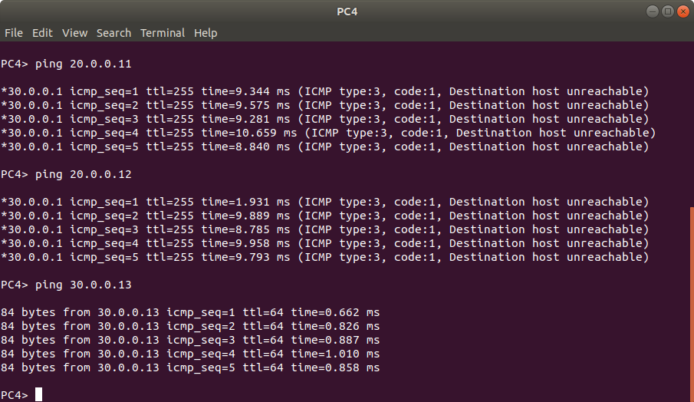

Across all the outputs of the pings from all the PCs, note that the PCs on a local network can communicate but the rest can’t.

The ping result of “Destination host unreachable” means that the PC does not know how to reach the specified IP (or if it even exists).

This is because the routing tables of the router need to be configured to allow communication with the two groups.

If only one of the routing tables are configured, then the ping message will go, but the response will not be able to travel. Hence, we should see a timeout error. To demonstrate, configure the routing tables only on Router 1

**On router 1:**

conf t ip route 30.0.0.0 255.0.0.0 10.0.0.2



Now if we try to ping from PC1/2 to PC3/4, we will get a timeout error **On PC1:**

|  |  |
| --- | --- |
| ping 30.0.0.13 | // PC3 |
| ping 30.0.0.14 | // PC4 |

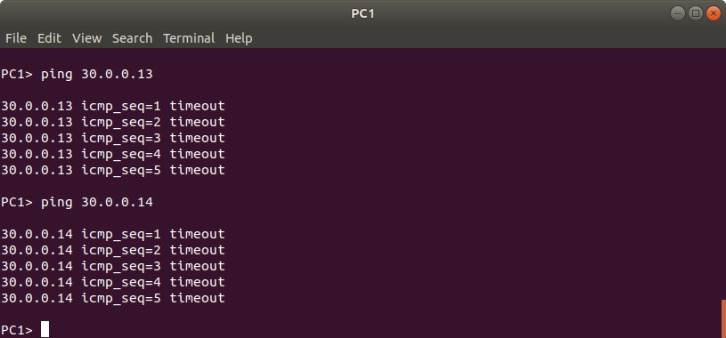

**On PC2:**

ping 30.0.0.13 ping 30.0.0.14

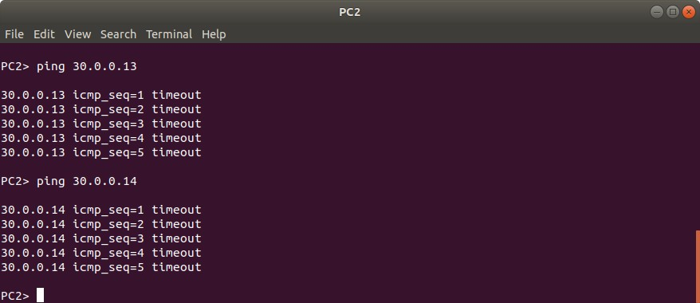

To succesfully communicate between all the PCs, all the routers routing tables need to be configured.

Now if we configure the routing table of router 2 as well, then we will see succesfull communication between PC1/2 and PC3/4

**On router 2:**

conf t ip route 20.0.0.0 255.0.0.0 10.0.0.1



Now, all 4 PCs can communicate with each other

To check, ping PC3/4 from PC1/2 and vice versa

**On PC1:**

|  |  |
| --- | --- |
| ping 30.0.0.13 | // PC3 |
| ping 30.0.0.14 | // PC4 |

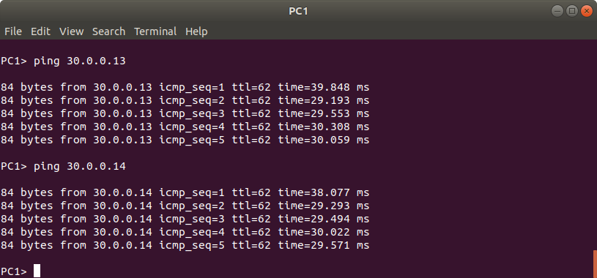

**On PC2:**

|  |  |
| --- | --- |
| ping 30.0.0.13 | // PC3 |
| ping 30.0.0.14 | // PC4 |

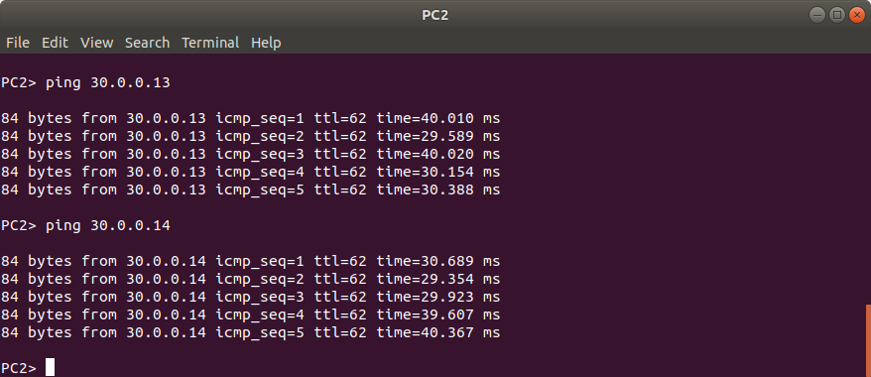

**On PC3:**

|  |  |
| --- | --- |
| ping 20.0.0.11 | // PC1 |
| ping 20.0.0.12 | // PC2 |

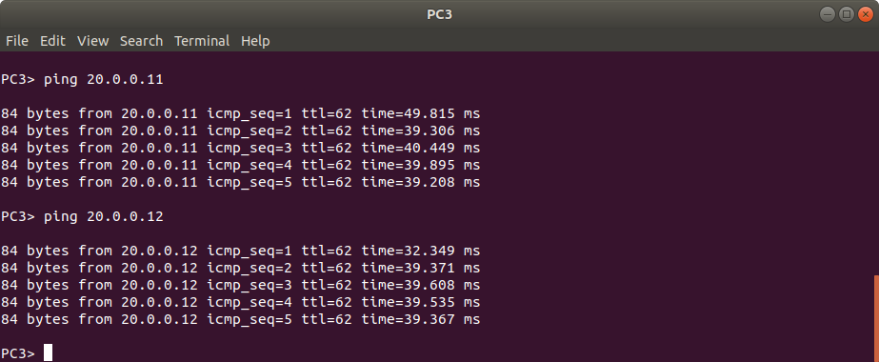

**On PC4:**

|  |  |
| --- | --- |
| ping 20.0.0.11 | // PC1 |
| ping 20.0.0.12 | // PC2 |

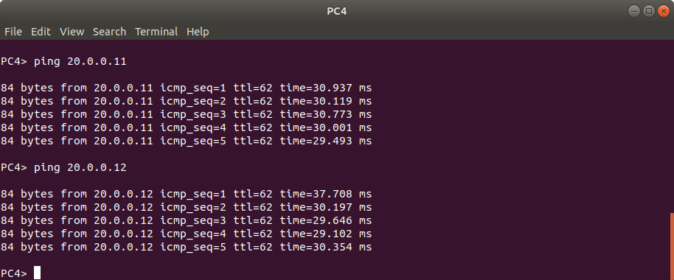

As an additional note:

One can see the obvious difference in the time taken for the reponse when communicating with a PC on a different network when compared to a PC on the same local network by comparing the screenshots here in the end and when we first tried to communicate with all the PCs at the start.

(Look the response time from the ping to PC on the same network vs different network)